PROGRESS TEST 1

Đoàn Nam Sơn

DE180896

Result:



------------------------------------------------------------------------------------------------------------------

Result:

Code:

------------------------------------------------------------------------------------------------------------------

Result:

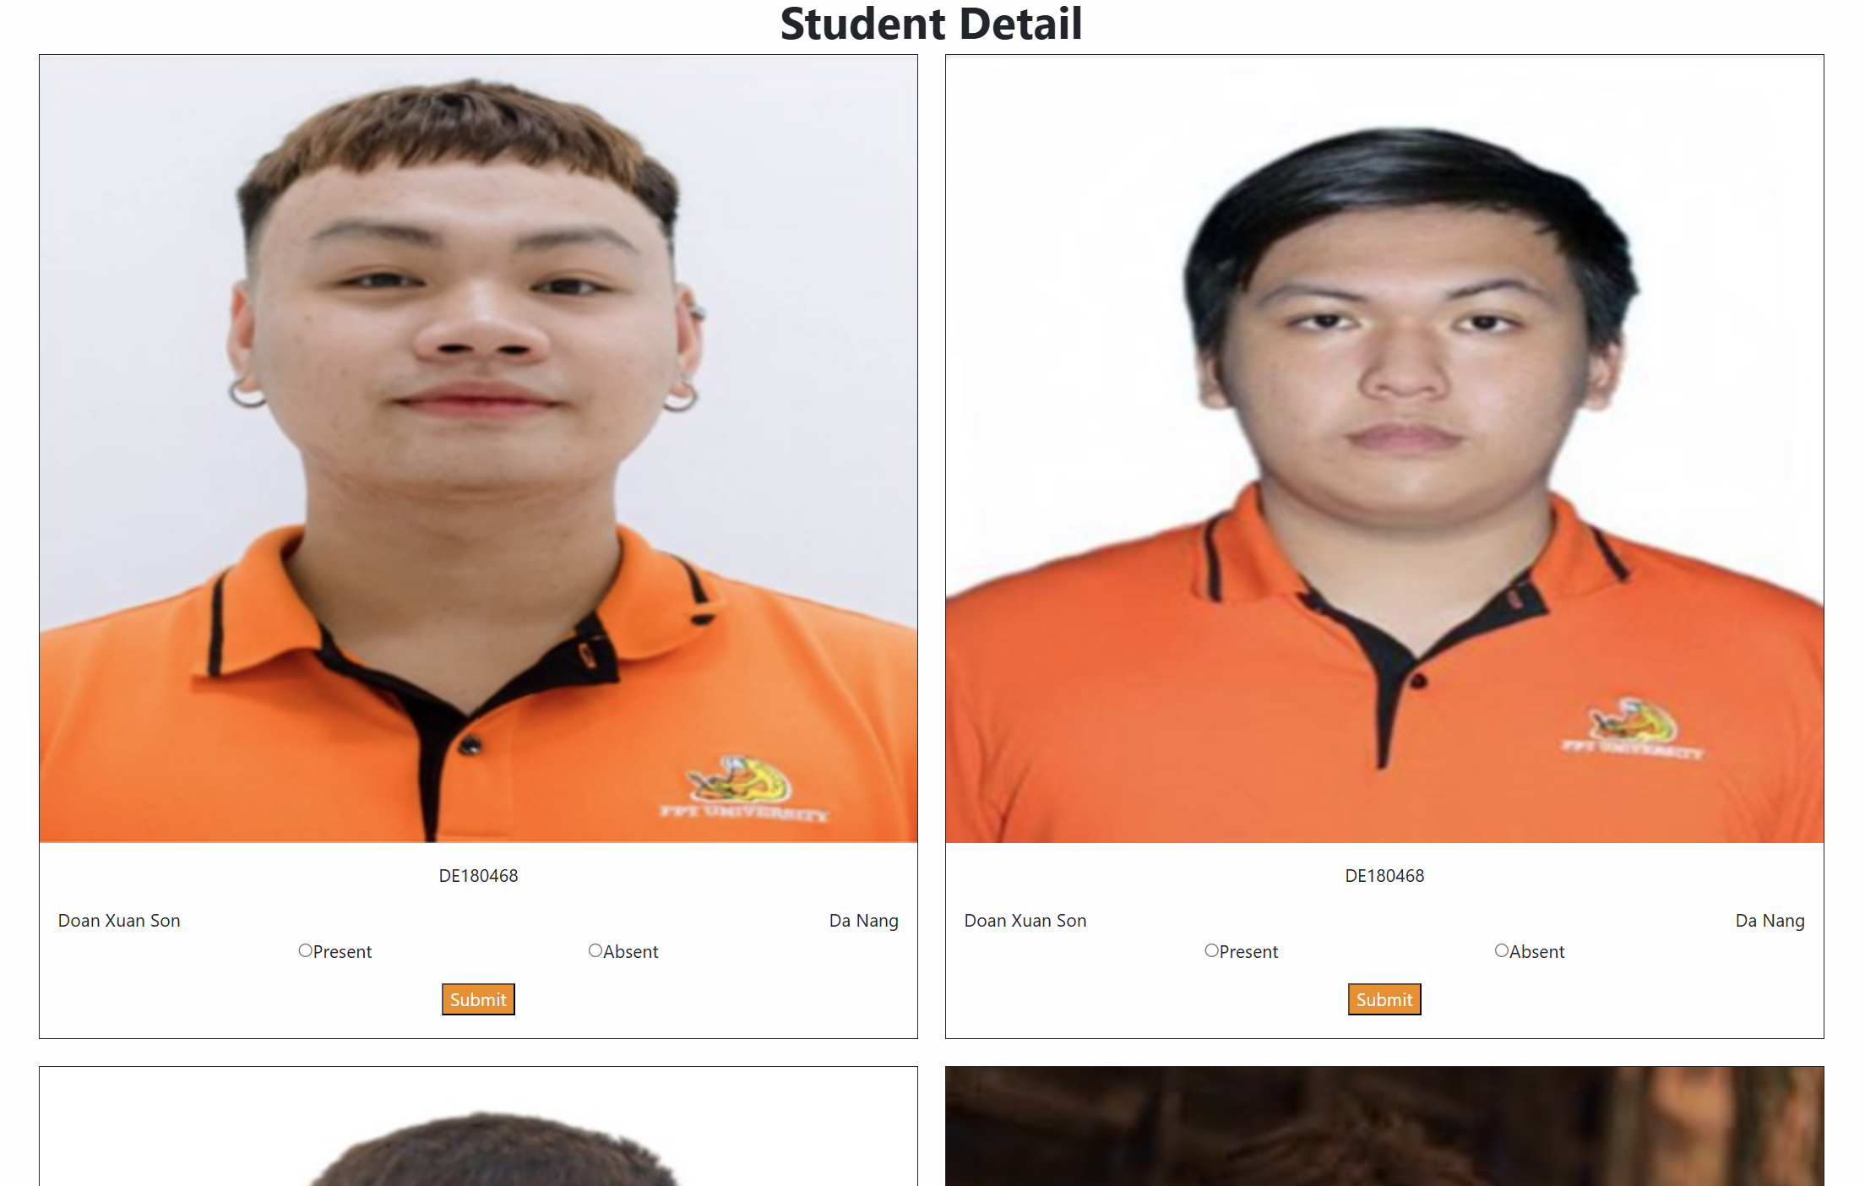

Code:

------------------------------------------------------------------------------------------------------------------

Result:



Code:

------------------------------------------------------------------------------------------------------------------

Code App.js and CSS

